**Efficient Anonymous Message Submission**

**CONTENTS**

**1. INTRODUCTION**

**2. ORGANIZATION PROFILE**

**3. SYSTEM ANALYSIS**

**3.1 Existing System 3.2 Limitations**

**3.3 Proposed System**

**3.4 Advantages of proposed system**

**4. problem formulation**

**4.1 Objectives**

**4.2 Hardware Specification**

**4.3 Software Specification 4.4 Software Descriptions**

**5. SYSTEM DESIGN**

**5.1 Design Overview**

**5.2 Context Analysis Diagram**

**5.3 Data Flow Diagram**

**5.4 Architecture Design**

**6. SYSTEM TESTING**

**6.1 Unit Testing**

**6.2 Integration Testing**

**6.3 Acceptance Testing**

**7. SYSTEM IMPLMENTATION**

**8. CONCLUSION**

**10. BIBLIOGRAPHY**

**11. APPENDICES**

**APPENDIX A: SAMPLE SCREENS**

**INTRODUCTION**

In the real world, anonymity has always been an important societal issue. As more and more people discover the digital world and find the need for anonymous participation, this issue is becoming increasingly important in this new society. For example, a company wants to collect opinions from its employees about its managers using an online system. However, employees may be scared to reveal their true opinions in fear of retribution from their managers if they were to find that they negatively answered the survey. As another example, consider a health research group who wants to collect individual health information from a survey group. The participants might not willing to provide their health information if their identities will be exposed during the information submission process. These examples show that a mechanism for anonymous message submission is thus necessary and significant.

It is easy to anonymously submit messages in the real world when compared with the same task in a public network. For example, in the real world, the collector just hands out the questionnaires and lets the group members fill them out. When the members submit their questionnaires, they first put them in a ballot box and then shake the box to shuffle the sheets before they submit them to the collector. However, if the collector wants to do it online, it becomes challenging because 1) a secure ballot box, which is actually a third storage facility, is hard to find, and 2) the shaking and shuffling activities are under all members’ surveillance, which is difficult to implement in a distributed network.

In Yang et al. proposed the first solution for online anonymous message submission. Bickell and Shmatikov revisited this problem and proposed a collusion resistant anonymous data collection protocol .Recently, Corrigan-Gibbs and Ford improved the protocol in to make it accountable and added the ability to send messages of variable lengths. Anonymity in the above protocols is guaranteed by “shuffling”, which is done by the group members themselves. Using the IND-CCA2 secure cryptosystem, existing collusion resistant Solutions. Can only be used in a small and private group, and have linear communication rounds in the group size.

The objective of this work is therefore to find an efficient construction of a collusion resistant anonymous message submission protocol for a group of a practical scale, whose size is usually on a scale as large as ten thousand. Although accountability is a desirable property for anonymous message submission, our work focuses on improving the performance of the anonymous message submission, which can then be extended to be accountable by using standard audit trail technique . We propose a novel technique which secretly aggregates the group members’ messages into a message vector so that each member is unaware of other members’ message positions. The security primitives employed in our protocol are the simplified secret sharing scheme and a symmetric key cryptosystem, both of which can be efficiently implemented and thus help our protocol fit a practical scale. This work aims to promote the practical application of anonymous message submission, which will then increase the privacy protection and anonymity in the network.

Our contributions are as follows:

1) We propose a novel anonymous position application technique, which can help every group member find a position in a position vector in a manner that every member is oblivious to the positions of the other members. This technique can be done in a few communication rounds with a high probability of success (2 rounds with a 95% success probability).

2) We propose an efficient anonymous message submission protocol for groups with a practical scale. Our protocol runs in polynomial time in the group size and constant communication rounds with a high probability.

3) We prove that our protocol is anonymous and collusion resistant under malicious attacks. The security of our protocol is based on the security of the secret sharing scheme and the symmetric key cryptosystem.

4) We analyze the performance of our protocol from the aspects of security and efficiency. Our simulation results show that our protocol is more efficient than the existing works, especially when the group size is large. More specifically, the computation of the collector in our protocol can achieve linear time complexity compared to the polynomial time complexity.

**ORGANISATION PROFILE**

skdotCom Technologies has a rich background in Software Development and continues its entire attention on achieving transcending excellence in the Development and Maintenance of Software Projects and Products in Many Areas. Some of them are ERP, Banking, Manufacturing, Insurance and Laying Emphasis on the Multimedia Projects. These projects are prevalent and have been distributed and implemented for clients world over. Major software Development Park at Kodambakkam, Chennai, India.

I.       Genesis

Elucidating the Aborigines of the Company, skdotCom Technologies, was initially dotCom IT Jobs Consultancy.

After stabilizing the skdotCom Products, Mr. P. Sivakumar M.C.A started giving Counseling Services in the name of skdotCom Agency, privately handled several Projects for leading Companies like Alstom, MRL and Spencers. DSEL has confronted challenges and rooted itself has a niche player in the Multimedia and the Business Software Segment. The Level of performed has been exemplary leaving it to nothing than the best of benchmark.

The indispensable factors, which give DSEL the competitive advantages over others in the market may be slated as :

•        Performance

•        Pioneering efforts

•        Client satisfaction

•        Innovative concepts

•        Constant Evaluations

•        Improvisation

•        Cost Effectiveness

  II.    Comparison Mission Statement

“To help customer optimize their investments in information technology, to help them gain a competitive edge in the market place.”

 III. Quality policy

  “To help our stock holders by regularly reviewing and improving our process.”

  IV.  Infrastructure

  Nested in an area with built-in area of 2,400 sq.ft. The park has encountered itself with computing resources that include from IBM. Besides, it also houses HP/9000, Sun Sparch, DEC Alpha System and over 500 IBM PS/VP nodes over a Heterogeneous Fiber Optic Network. Operating system is used varied from MVS and Aix through OS/400 and OS/2 to SOLARIS, UNIX and Windows with range of RDBMS, Languages and Case tools.

Major Functions / Activities at skdotCom

  Only a few years ago, the World Wide Web was a very design unfriendly place. But with the advent of Images, Web Pages have become Interactive. This inter-activity is still limited. In its endeavor to make the Internet more Interactive Exciting, skdotCom Technologies has set up the Internet Team.

**SYSTEM ANALYSIS**

**Existing System:**

Existing solutions let each member blindly shuffle the submitted messages by using the IND-CCA2 secure cryptosystem. In the end, all messages are randomly shuffled and no one knows the message order. However, the heavy computational overhead and linear communication rounds make it only useful for small groups.

**Proposed System:**

We propose an efficient anonymous message submission protocol aimed at a practical group size. Our protocol is based on a simplified secret sharing scheme and a symmetric key cryptosystem. We propose a novel method to let all members secretly aggregate their messages into a message vector such that a member knows nothing about other members’ message positions. We provide a theoretical proof showing that our protocol is anonymous under malicious attacks. We then conduct a thorough analysis of our protocol, showing that our protocol is computationally more efficient than existing solutions and results in a constant communication rounds with a high probability. We propose security sharing scheme using some protocol.

**problem formulation**

# H/W System Configuration:-

**Speed - 1.1 Ghz**

**RAM - 256 MB(min)**

**Hard Disk - 20 GB**

**Floppy Drive - 1.44 MB**

**Key Board - Standard Windows Keyboard**

**Mouse - Two or Three Button Mouse**

**Monitor - SVGA**

# S/W System Configuration:-

* Operating System :Windows95/98/2000/XP
* Application Server : Tomcat7
* Front End : Struts, HTML, Java, Jsp
* Scripts : JavaScript.
* Server side Script : Java Server Pages.
* Database : Mysql
* Database Connectivity : JDBC.

**4.4 Software Environment**

## Java Technology

Java technology is both a programming language and a platform.

### The Java Programming Language

### The Java programming language is a high-level language that can be characterized by all of the following buzzwords:

* + - Simple
    - Architecture neutral
    - Object oriented
    - Portable
    - Distributed
    - High performance
    - Interpreted
    - Multithreaded
    - Robust
    - Dynamic
    - Secure

With most programming languages, you either compile or interpret a program so that you can run it on your computer. The Java programming language is unusual in that a program is both compiled and interpreted. With the compiler, first you translate a program into an intermediate language called Java byte codes —the platform-independent codes interpreted by the interpreter on the Java platform. The interpreter parses and runs each Java byte code instruction on the computer. Compilation happens just once; interpretation occurs each time the program is executed. The following figure illustrates how this works.

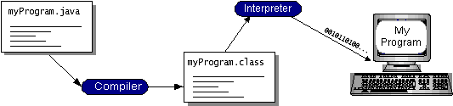

You can think of Java bytecodes as the machine code instructions for the Java Virtual Machine (Java VM). Every Java interpreter, whether it’s a development tool or a Web browser that can run applets, is an implementation of the Java VM. Java bytecodes help make “write once, run anywhere” possible. You can compile your program into bytecodes on any platform that has a Java compiler. The bytecodes can then be run on any implementation of the Java VM. That means that as long as a computer has a Java VM, the same program written in the Java programming language can run on Windows 2000, a Solaris workstation, or on an iMac.

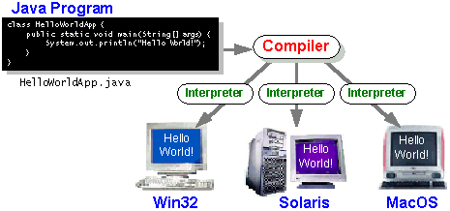

### The Java Platform

A platform is the hardware or software environment in which a program runs. We’ve already mentioned some of the most popular platforms like Windows 2000, Linux, Solaris, and MacOS. Most platforms can be described as a combination of the operating system and hardware. The Java platform differs from most other platforms in that it’s a software-only platform that runs on top of other hardware-based platforms.

The Java platform has two components:

* The Java Virtual Machine (Java VM)
* The Java Application Programming Interface (Java API)

You’ve already been introduced to the Java VM. It’s the base for the Java platform and is ported onto various hardware-based platforms.

The Java API is a large collection of ready-made software components that provide many useful capabilities, such as graphical user interface (GUI) widgets. The Java API is grouped into libraries of related classes and interfaces; these libraries are known as packages. The next section, What Can Java Technology Do?, highlights what functionality some of the packages in the Java API provide.

The following figure depicts a program that’s running on the Java platform. As the figure shows, the Java API and the virtual machine insulate the program from the hardware.

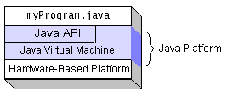

Native code is code that after you compile it, the compiled code runs on a specific hardware platform. As a platform-independent environment, the Java platform can be a bit slower than native code. However, smart compilers, well-tuned interpreters, and just-in-time bytecode compilers can bring performance close to that of native code without threatening portability.

## What Can Java Technology Do?

The most common types of programs written in the Java programming language are applets and applications. If you’ve surfed the Web, you’re probably already familiar with applets. An applet is a program that adheres to certain conventions that allow it to run within a Java-enabled browser.

However, the Java programming language is not just for writing cute, entertaining applets for the Web. The general-purpose, high-level Java programming language is also a powerful software platform. Using the generous API, you can write many types of programs.

An application is a standalone program that runs directly on the Java platform. A special kind of application known as a server serves and supports clients on a network. Examples of servers are Web servers, proxy servers, mail servers, and print servers. Another specialized program is a servlet. A servlet can almost be thought of as an applet that runs on the server side. Java Servlets are a popular choice for building interactive web applications, replacing the use of CGI scripts. Servlets are similar to applets in that they are runtime extensions of applications. Instead of working in browsers, though, servlets run within Java Web servers, configuring or tailoring the server.

How does the API support all these kinds of programs? It does so with packages of software components that provide a wide range of functionality. Every full implementation of the Java platform gives you the following features:

* **The essentials**: Objects, strings, threads, numbers, input and output, data structures, system properties, date and time, and so on.
* **Applets**: The set of conventions used by applets.
* **Networking**: URLs, TCP (Transmission Control Protocol), UDP (User Data gram Protocol) sockets, and IP (Internet Protocol) addresses.
* **Internationalization**: Help for writing programs that can be localized for users worldwide. Programs can automatically adapt to specific locales and be displayed in the appropriate language.
* **Security**: Both low level and high level, including electronic signatures, public and private key management, access control, and certificates.
* **Software components**: Known as JavaBeansTM, can plug into existing component architectures.
* **Object serialization**: Allows lightweight persistence and communication via Remote Method Invocation (RMI).
* **Java Database Connectivity (JDBCTM)**: Provides uniform access to a wide range of relational databases.

The Java platform also has APIs for 2D and 3D graphics, accessibility, servers, collaboration, telephony, speech, animation, and more. The following figure depicts what is included in the Java 2 SDK.

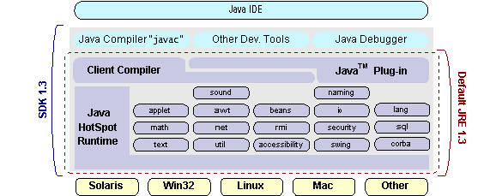

## How Will Java Technology Change My Life?

We can’t promise you fame, fortune, or even a job if you learn the Java programming language. Still, it is likely to make your programs better and requires less effort than other languages. We believe that Java technology will help you do the following:

* **Get started quickly**: Although the Java programming language is a powerful object-oriented language, it’s easy to learn, especially for programmers already familiar with C or C++.
* **Write less code**: Comparisons of program metrics (class counts, method counts, and so on) suggest that a program written in the Java programming language can be four times smaller than the same program in C++.
* **Write better code**: The Java programming language encourages good coding practices, and its garbage collection helps you avoid memory leaks. Its object orientation, its JavaBeans component architecture, and its wide-ranging, easily extendible API let you reuse other people’s tested code and introduce fewer bugs.
* **Develop programs more quickly**: Your development time may be as much as twice as fast versus writing the same program in C++. Why? You write fewer lines of code and it is a simpler programming language than C++.
* **Avoid platform dependencies with 100% Pure Java**: You can keep your program portable by avoiding the use of libraries written in other languages. The 100% Pure JavaTM Product Certification Program has a repository of historical process manuals, white papers, brochures, and similar materials online.
* **Write once, run anywhere**: Because 100% Pure Java programs are compiled into machine-independent bytecodes, they run consistently on any Java platform.
* **Distribute software more easily**: You can upgrade applets easily from a central server. Applets take advantage of the feature of allowing new classes to be loaded “on the fly,” without recompiling the entire program.

### ODBC

Microsoft Open Database Connectivity (ODBC) is a standard programming interface for application developers and database systems providers. Before ODBC became a *de facto* standard for Windows programs to interface with database systems, programmers had to use proprietary languages for each database they wanted to connect to. Now, ODBC has made the choice of the database system almost irrelevant from a coding perspective, which is as it should be. Application developers have much more important things to worry about than the syntax that is needed to port their program from one database to another when business needs suddenly change.

Through the ODBC Administrator in Control Panel, you can specify the particular database that is associated with a data source that an ODBC application program is written to use. Think of an ODBC data source as a door with a name on it. Each door will lead you to a particular database. For example, the data source named Sales Figures might be a SQL Server database, whereas the Accounts Payable data source could refer to an Access database. The physical database referred to by a data source can reside anywhere on the LAN.

The ODBC system files are not installed on your system by Windows 95. Rather, they are installed when you setup a separate database application, such as SQL Server Client or Visual Basic 4.0. When the ODBC icon is installed in Control Panel, it uses a file called ODBCINST.DLL. It is also possible to administer your ODBC data sources through a stand-alone program called ODBCADM.EXE. There is a 16-bit and a 32-bit version of this program, and each maintains a separate list of ODBC data sources.

From a programming perspective, the beauty of ODBC is that the application can be written to use the same set of function calls to interface with any data source, regardless of the database vendor. The source code of the application doesn’t change whether it talks to Oracle or SQL Server. We only mention these two as an example. There are ODBC drivers available for several dozen popular database systems. Even Excel spreadsheets and plain text files can be turned into data sources. The operating system uses the Registry information written by ODBC Administrator to determine which low-level ODBC drivers are needed to talk to the data source (such as the interface to Oracle or SQL Server). The loading of the ODBC drivers is transparent to the ODBC application program. In a client/server environment, the ODBC API even handles many of the network issues for the application programmer.

The advantages of this scheme are so numerous that you are probably thinking there must be some catch. The only disadvantage of ODBC is that it isn’t as efficient as talking directly to the native database interface. ODBC has had many detractors make the charge that it is too slow. Microsoft has always claimed that the critical factor in performance is the quality of the driver software that is used. In our humble opinion, this is true. The availability of good ODBC drivers has improved a great deal recently. And anyway, the criticism about performance is somewhat analogous to those who said that compilers would never match the speed of pure assembly language. Maybe not, but the compiler (or ODBC) gives you the opportunity to write cleaner programs, which means you finish sooner. Meanwhile, computers get faster every year.

**JDBC**

In an effort to set an independent database standard API for Java, Sun Microsystems developed Java Database Connectivity, or JDBC. JDBC offers a generic SQL database access mechanism that provides a consistent interface to a variety of RDBMSs. This consistent interface is achieved through the use of “plug-in” database connectivity modules, or *drivers*. If a database vendor wishes to have JDBC support, he or she must provide the driver for each platform that the database and Java run on.

To gain a wider acceptance of JDBC, Sun based JDBC’s framework on ODBC. As you discovered earlier in this chapter, ODBC has widespread support on a variety of platforms. Basing JDBC on ODBC will allow vendors to bring JDBC drivers to market much faster than developing a completely new connectivity solution.

JDBC was announced in March of 1996. It was released for a 90 day public review that ended June 8, 1996. Because of user input, the final JDBC v1.0 specification was released soon after.

The remainder of this section will cover enough information about JDBC for you to know what it is about and how to use it effectively. This is by no means a complete overview of JDBC. That would fill an entire book.

### JDBC Goals

Few software packages are designed without goals in mind. JDBC is one that, because of its many goals, drove the development of the API. These goals, in conjunction with early reviewer feedback, have finalized the JDBC class library into a solid framework for building database applications in Java.

The goals that were set for JDBC are important. They will give you some insight as to why certain classes and functionalities behave the way they do. The eight design goals for JDBC are as follows:

1. ***SQL Level API***

The designers felt that their main goal was to define a SQL interface for Java. Although not the lowest database interface level possible, it is at a low enough level for higher-level tools and APIs to be created. Conversely, it is at a high enough level for application programmers to use it confidently. Attaining this goal allows for future tool vendors to “generate” JDBC code and to hide many of JDBC’s complexities from the end user.

1. ***SQL Conformance***

SQL syntax varies as you move from database vendor to database vendor. In an effort to support a wide variety of vendors, JDBC will allow any query statement to be passed through it to the underlying database driver. This allows the connectivity module to handle non-standard functionality in a manner that is suitable for its users.

1. ***JDBC must be implemental on top of common database interfaces***The JDBC SQL API must “sit” on top of other common SQL level APIs. This goal allows JDBC to use existing ODBC level drivers by the use of a software interface. This interface would translate JDBC calls to ODBC and vice versa.
2. ***Provide a Java interface that is consistent with the rest of the Java system***

Because of Java’s acceptance in the user community thus far, the designers feel that they should not stray from the current design of the core Java system.

1. ***Keep it simple***

This goal probably appears in all software design goal listings. JDBC is no exception. Sun felt that the design of JDBC should be very simple, allowing for only one method of completing a task per mechanism. Allowing duplicate functionality only serves to confuse the users of the API.

1. ***Use strong, static typing wherever possible***

Strong typing allows for more error checking to be done at compile time; also, less errors appear at runtime.

1. ***Keep the common cases simple***

Because more often than not, the usual SQL calls used by the programmer are simple SELECT’s, INSERT’s, DELETE’s and UPDATE’s, these queries should be simple to perform with JDBC. However, more complex SQL statements should also be possible.

Finally we decided to proceed the implementation using Java Networking.

And for dynamically updating the cache table we go for MS Access database .

Java ha two things: a programming language and a platform.

Java is a high-level programming language that is all of the following

Simple Architecture-neutral

Object-oriented Portable

Distributed High-performance

Interpreted multithreaded

Robust Dynamic

Secure

Java is also unusual in that each Java program is both compiled and interpreted. With a compile you translate a Java program into an intermediate language called Java byte codes the platform-independent code instruction is passed and run on the computer.

Compilation happens just once; interpretation occurs each time the program is executed. The figure illustrates how this works.

**Java Program**

**Compilers**

**Interpreter**

**My Program**

You can think of Java byte codes as the machine code instructions for the Java Virtual Machine (Java VM). Every Java interpreter, whether it’s a Java development tool or a Web browser that can run Java applets, is an implementation of the Java VM. The Java VM can also be implemented in hardware.

Java byte codes help make “write once, run anywhere” possible. You can compile your Java program into byte codes on my platform that has a Java compiler. The byte codes can then be run any implementation of the Java VM. For example, the same Java program can run Windows NT, Solaris, and Macintosh.

## Networking

### TCP/IP stack

The TCP/IP stack is shorter than the OSI one:

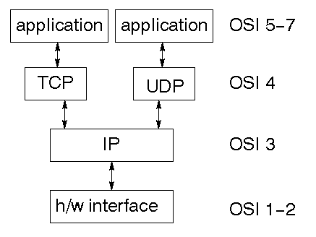

TCP is a connection-oriented protocol; UDP (User Datagram Protocol) is a connectionless protocol.

### IP datagram’s

The IP layer provides a connectionless and unreliable delivery system. It considers each datagram independently of the others. Any association between datagram must be supplied by the higher layers. The IP layer supplies a checksum that includes its own header. The header includes the source and destination addresses. The IP layer handles routing through an Internet. It is also responsible for breaking up large datagram into smaller ones for transmission and reassembling them at the other end.

### UDP

UDP is also connectionless and unreliable. What it adds to IP is a checksum for the contents of the datagram and port numbers. These are used to give a client/server model - see later.

### TCP

TCP supplies logic to give a reliable connection-oriented protocol above IP. It provides a virtual circuit that two processes can use to communicate.

### Internet addresses

In order to use a service, you must be able to find it. The Internet uses an address scheme for machines so that they can be located. The address is a 32 bit integer which gives the IP address. This encodes a network ID and more addressing. The network ID falls into various classes according to the size of the network address.

### Network address

Class A uses 8 bits for the network address with 24 bits left over for other addressing. Class B uses 16 bit network addressing. Class C uses 24 bit network addressing and class D uses all 32.

### Subnet address

Internally, the UNIX network is divided into sub networks. Building 11 is currently on one sub network and uses 10-bit addressing, allowing 1024 different hosts.

### Host address

8 bits are finally used for host addresses within our subnet. This places a limit of 256 machines that can be on the subnet.

### Total address

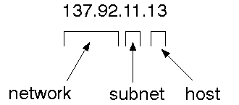

The 32 bit address is usually written as 4 integers separated by dots.

### Port addresses

A service exists on a host, and is identified by its port. This is a 16 bit number. To send a message to a server, you send it to the port for that service of the host that it is running on. This is not location transparency! Certain of these ports are "well known".

### Sockets

A socket is a data structure maintained by the system to handle network connections. A socket is created using the call socket. It returns an integer that is like a file descriptor. In fact, under Windows, this handle can be used with Read File and Write File functions.

#include <sys/types.h>

#include <sys/socket.h>

int socket(int family, int type, int protocol);

Here "family" will be AF_INET for IP communications, protocol will be zero, and type will depend on whether TCP or UDP is used. Two processes wishing to communicate over a network create a socket each. These are similar to two ends of a pipe - but the actual pipe does not yet exist.

**SYSTEM DESIGN**

**Data Flow Diagram:**

**SYSTEM DESIGN :(** Admin**)**



User



Collector



User Case Diagram



Class Diagram



Activity Diagram



Sequence Diagram



### SYSTEM TESTING

The purpose of testing is to discover errors. Testing is the process of trying to discover every conceivable fault or weakness in a work product. It provides a way to check the functionality of components, sub assemblies, assemblies and/or a finished product It is the process of exercising software with the intent of ensuring that the

Software system meets its requirements and user expectations and does not fail in an unacceptable manner. There are various types of test. Each test type addresses a specific testing requirement.

**TYPES OF TESTS**

**Unit testing**

Unit testing involves the design of test cases that validate that the internal program logic is functioning properly, and that program input produce valid outputs. All decision branches and internal code flow should be validated. It is the testing of individual software units of the application .it is done after the completion of an individual unit before integration. This is a structural testing, that relies on knowledge of its construction and is invasive. Unit tests perform basic tests at component level and test a specific business process, application, and/or system configuration. Unit tests ensure that each unique path of a business process performs accurately to the documented specifications and contains clearly defined inputs and expected results.

**Integration testing**

Integration tests are designed to test integrated software components to determine if they actually run as one program. Testing is event driven and is more concerned with the basic outcome of screens or fields. Integration tests demonstrate that although the components were individually satisfaction, as shown by successfully unit testing, the combination of components is correct and consistent. Integration testing is specifically aimed at exposing the problems that arise from the combination of components.

**Functional test**

Functional tests provide a systematic demonstrations that functions tested are available as specified by the business and technical requirements, system documentation , and user manuals.

Functional testing is centered on the following items:

Valid Input : identified classes of valid input must be accepted.

Invalid Input : identified classes of invalid input must be rejected.

Functions : identified functions must be exercised.

Output : identified classes of application outputs must be exercised.

Systems/Procedures : interfacing systems or procedures must be invoked.

Organization and preparation of functional tests is focused on requirements, key functions, or special test cases. In addition, systematic coverage pertaining to identify

Business process flows; data fields, predefined processes, and successive processes must be considered for testing. Before functional testing is complete, additional tests are identified and the effective value of current tests is determined.

**System Test**

System testing ensures that the entire integrated software system meets requirements. It tests a configuration to ensure known and predictable results. An example of system testing is the configuration oriented system integration test. System testing is based on process descriptions and flows, emphasizing pre-driven process links and integration points.

**White Box Testing**

White Box Testing is a testing in which in which the software tester has knowledge of the inner workings, structure and language of the software, or at least its purpose. It is purpose. It is used to test areas that cannot be reached from a black box level .

**Black Box Testing**

Black Box Testing is testing the software without any knowledge of the inner workings, structure or language of the module being tested . Black box tests, as most other kinds of tests, must be written from a definitive source document, such as specification or requirements document, such as specification or requirements document. It is a testing in which the software under test is treated, as a black box .you cannot “see” into it. The test provides inputs and responds to outputs without considering how the software works.

**Unit Testing:**

Unit testing is usually conducted as part of a combined code and unit test phase of the software lifecycle, although it is not uncommon for coding and unit testing to be conducted as two distinct phases.

**Test strategy and approach**

Field testing will be performed manually and functional tests will be written in detail.

**Test objectives**

* All field entries must work properly.
* Pages must be activated from the identified link.
* The entry screen, messages and responses must not be delayed.

**Features to be tested**

* Verify that the entries are of the correct format
* No duplicate entries should be allowed
* All links should take the user to the correct page.

# Integration Testing

Software integration testing is the incremental integration testing of two or more integrated software components on a single platform to produce failures caused by interface defects.

The task of the integration test is to check that components or software applications, e.g. components in a software system or – one step up – software applications at the company level – interact without error.

**Test Results:** All the test cases mentioned above passed successfully. No defects encountered.

**Acceptance Testing**

User Acceptance Testing is a critical phase of any project and requires significant participation by the end user. It also ensures that the system meets the functional requirements.

**Test Results:** All the test cases mentioned above passed successfully. No defects encountered.

### IMPLEMENTATION

Implementation is the stage of the project when the theoretical design is turned out into a working system. Thus it can be considered to be the most critical stage in achieving a successful new system and in giving the user, confidence that the new system will work and be effective.

The implementation stage involves careful planning, investigation of the existing system and it’s constraints on implementation, designing of methods to achieve changeover and evaluation of changeover methods.

Implementation is the process of converting a new system design into operation. It is the phase that focuses on user training, site preparation and file conversion for installing a candidate system. The important factor that should be considered here is that the conversion should not disrupt the functioning of the organization.

**CONCLUSION**

We have proposed an efficient online anonymous message protocol. Utilizing the simplified secret sharing scheme, we have presented a novel position application technique, in which all members secretly select their positions in a position vector, such that a member knows nothing about the other members’ message positions. We have introduced a data aggregation technique, in which all members aggregate their messages into a message vector and submit it to the collector without exposing their identities. We have theoretically proved that our protocol is anonymous under malicious attacks. Our efficiency analysis and simulation have shown that our protocol is computationally more efficient than existing works and requires a constant communication rounds on average.

**BIBLIOGRAPHY**

Good Teachers are worth more than thousand books, we have them in Our Department

**REFERENCES**

[1] R. Agrawal and R. Srikant, “Privacy-preserving data mining,” in SIGMOD, vol. 29, no. 2. ACM, 2000, pp. 439–450.

[2] M. Bellare, A. Desai, E. Jokipii, and P. Rogaway, “A concrete security treatment of symmetric encryption,” in focs. Published by the IEEE Computer Society, 1997, p. 394.

[3] J. Benaloh, “Secret sharing homomorphisms: Keeping shares of a secret secret (extended abstract),” in Advances in Cryptology?CRYPTO?86. Springer, 1987, pp. 251–260.

[4] M. Bodrato, “Towards optimal toom-cook multiplication for univariate and multivariate polynomials in characteristic 2 and 0,” Arithmetic of Finite Fields, pp. 116–133, 2007.

[5] J. Brickell and V. Shmatikov, “Efficient anonymity-preserving data collection,” in Proceedings of the 12th ACM SIGKDD. ACM, 2006, pp. 76–85.

[6] N. Cao, C. Wang, M. Li, K. Ren, and W. Lou, “Privacy-preserving multikeyword

ranked search over encrypted cloud data,” in INFOCOM, 2011

Proceedings IEEE. IEEE, 2011, pp. 829–837.

[7] D. Chaum, “Untraceable electronic mail, return addresses, and digital pseudonyms,” Communications of the ACM, vol. 24, no. 2, pp. 84–90, 1981.

[8] D. Chaum, “The dining cryptographers problem: Unconditional sender and recipient untraceability,” Journal of cryptology, vol. 1, no. 1, pp.

65–75, 1988.

[9] H. Corrigan-Gibbs and B. Ford, “Dissent: accountable anonymous group messaging,” in ACM CCS. ACM, 2010, pp. 340–350.

[10] Crypto++, http://www.cryptopp.com/, 2010.

[11] W. Du and M. Atallah, “Secure multi-party computation problems and their applications: a review and open problems,” in Proceedings of the 2001 workshop on New security paradigms. ACM, 2001, pp. 13–22.

[12] M. Freedman, K. Nissim, and B. Pinkas, “Efficient private matching and set intersection,” in Advances in Cryptology-EUROCRYPT 2004. Springer, 2004, pp. 1 19.

[13] O. Goldreich, “Secure multi-party computation,” Working Draft, 2000.

[14] S. Goldwasser and S. Micali, “Probabilistic encryption* 1,” Journal of computer and system sciences, vol. 28, no. 2, pp. 270–299, 1984.

[15] P. Golle and A. Juels, “Dining cryptographers revisited,” in Advances in Cryptology-Eurocrypt 2004. Springer, 2004, pp. 456–473.

[16] M. Li, N. Cao, S. Yu, and W. Lou, “Findu: Privacy-preserving personal profile matching in mobile social networks,” in Proc. of Infocom, 2011.

[17] Y. Lindell and B. Pinkas, “Privacy preserving data mining,” in Advances in Cryptology?CRYPTO 2000. Springer, 2000, pp. 36–54.

[18] A. Narayanan, N. Thiagarajan, M. Lakhani, M. Hamburg, and D. Boneh, “Location privacy via private proximity testing,” in Proc. of NDSS, 2011.

[19] T. Nishide and K. Ohta, “Multiparty computation for interval, equality, and comparison without bit-decomposition protocol,” Public Key Cryptography–PKC 2007, pp. 343–360, 2007.

[20] ns 2, http://www.isi.edu/nsnam/ns/.

[21] A. Shamir, “How to share a secret,” Communications of the ACM, vol. 22, no. 11, pp. 612–613, 1979.

[22] E. Sirer, S. Goel, M. Robson, and D. Engin, “Eluding carnivores: File sharing with strong anonymity,” in Proceedings of the 11th workshop on ACM SIGOPS European workshop. ACM, 2004, pp. 19–es.

[23] D. Stinson, Cryptography: theory and practice. CRC press, 2006.

[24] P. Syverson, D. Goldschlag, and M. Reed, “Onion routing for anonymous and private internet connections,” 1999.

[25] M.Waidner, B. Pfitzmann et al., “The dining cryptographers in the disco: Unconditional sender and recipient untraceability with computationally secure serviceability.”

[26] W. Wong, D. Cheung, B. Kao, and N. Mamoulis, “Secure knn computation on encrypted databases,” in SIGMOD. ACM, 2009, pp. 139–152.

[27] Z. Yang, S. Zhong, and R. Wright, “Anonymity-preserving data collection,” in ACM SIGKDD. ACM, 2005, pp. 334–343.

[28] A. Yao, “How to generate and exchange secrets,” in FOCS. IEEE, 1986, pp. 162–167. 2236

**Sites Referred:**

<http://java.sun.com>

<http://www.sourcefordgde.com>

<http://www.networkcomputing.com/>

<http://www.roseindia.com/>

<http://www.java2s.com/>

**APPENDICES**

**SAMPLE SCREENS**

**Screen shots**

**Home**

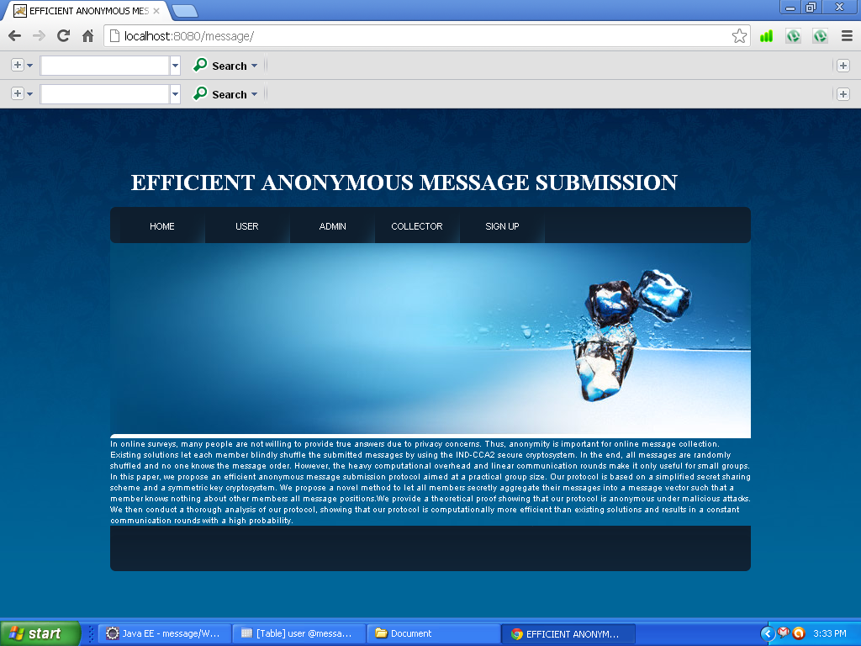

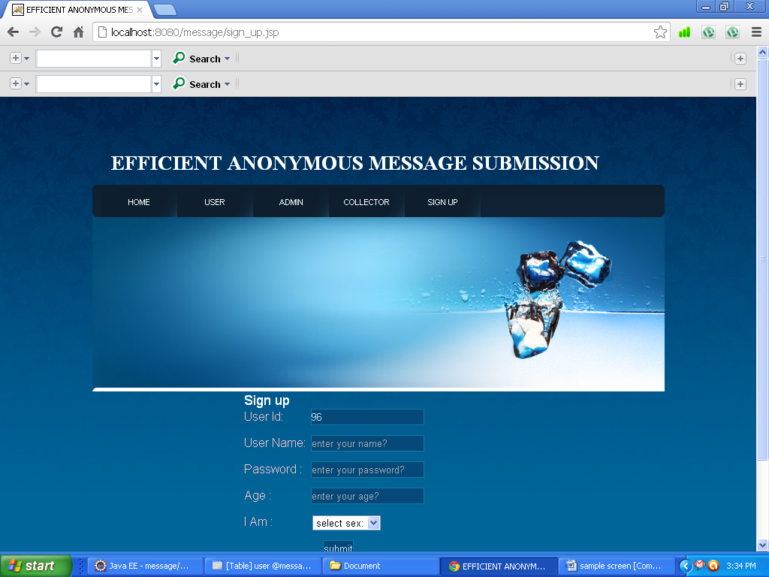

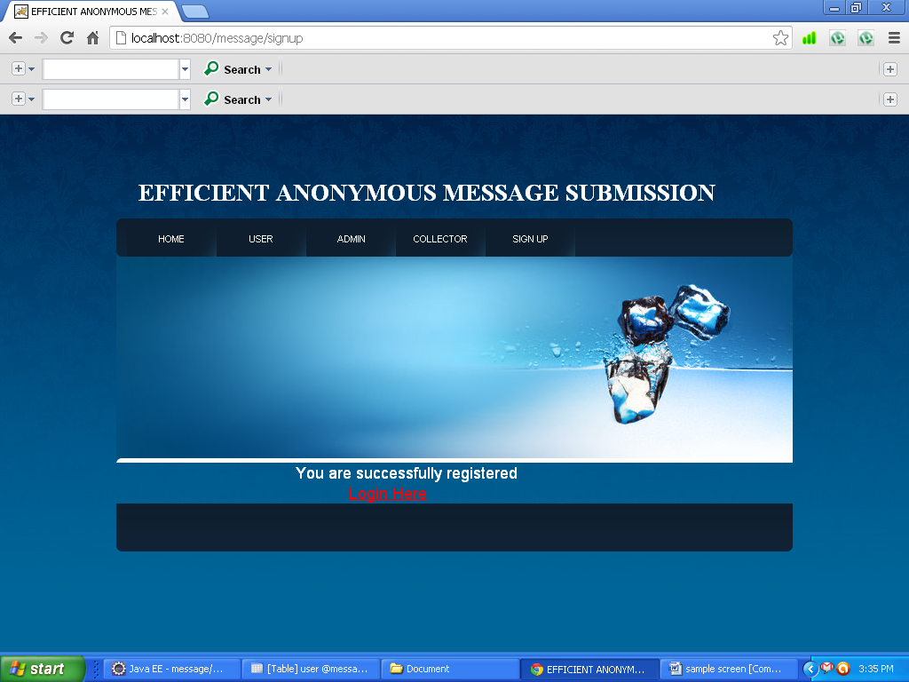

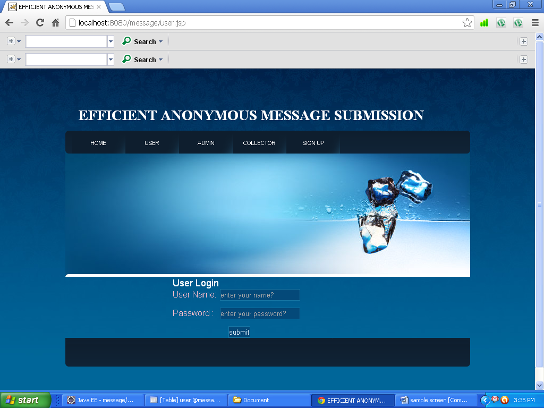

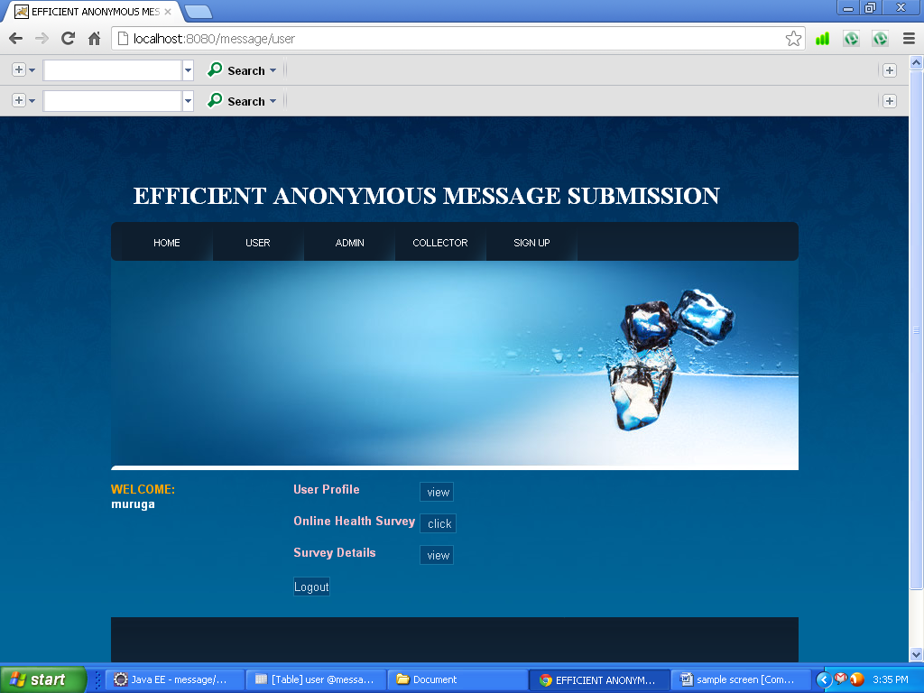

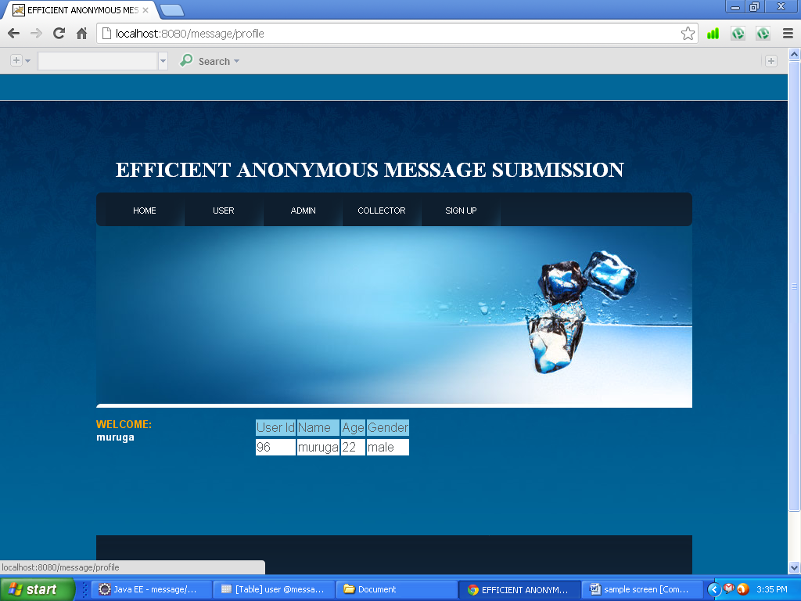

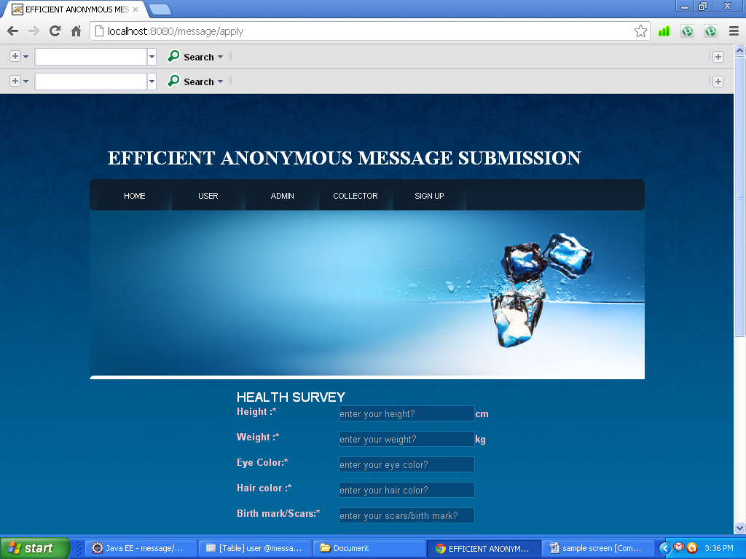

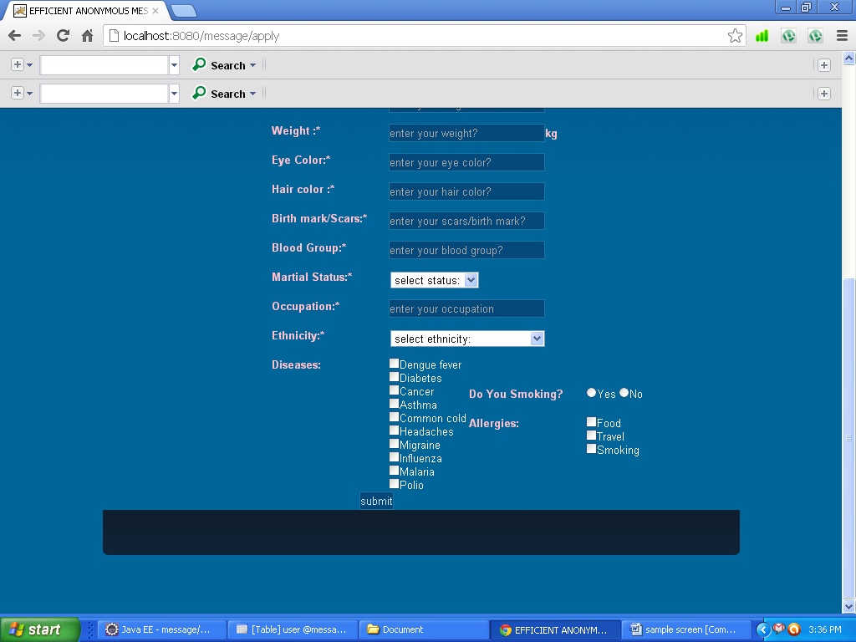

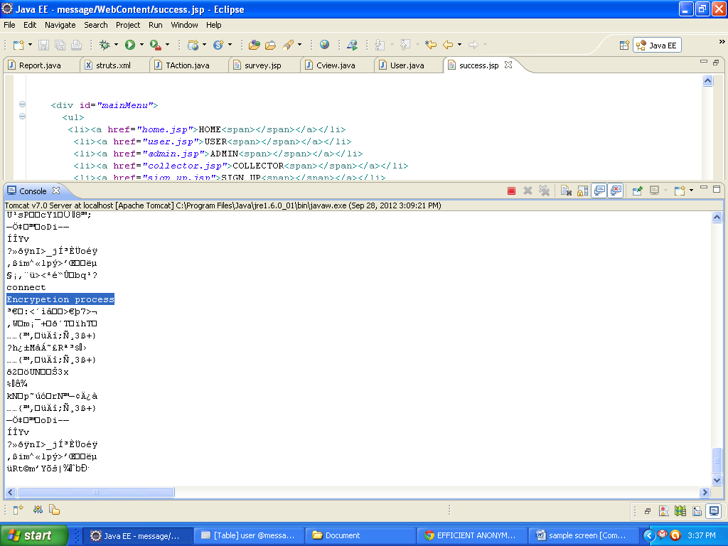

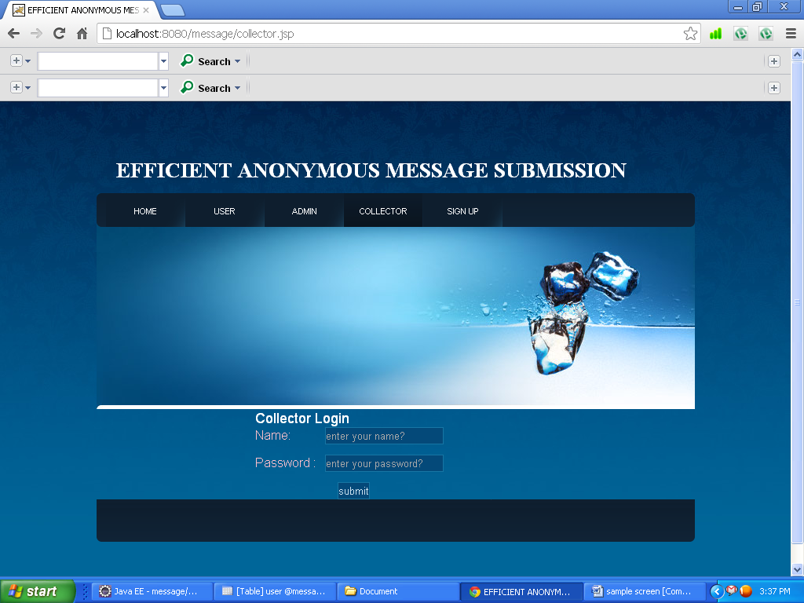

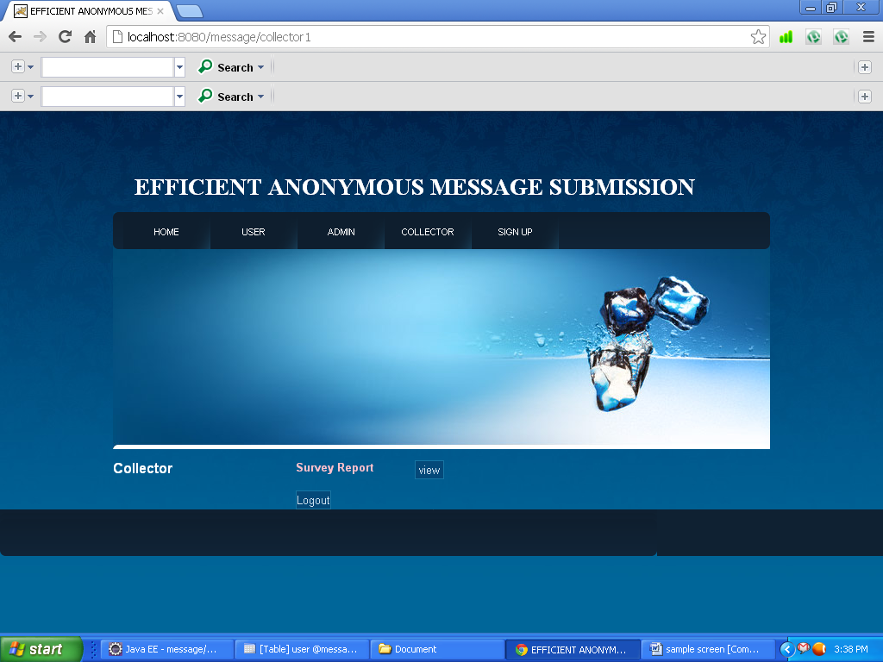

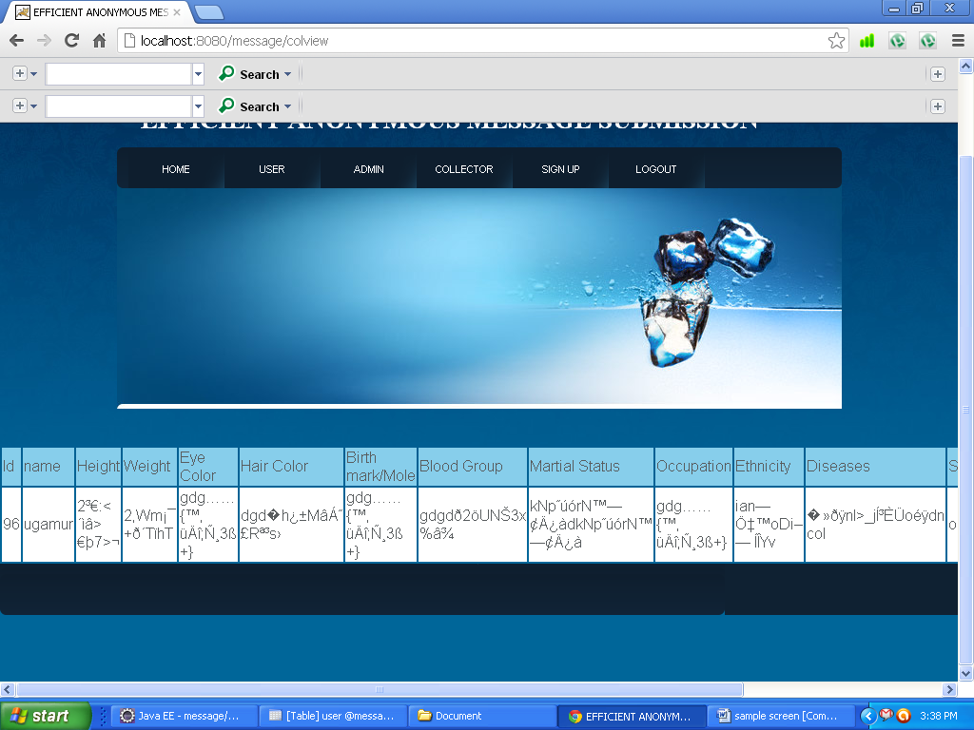

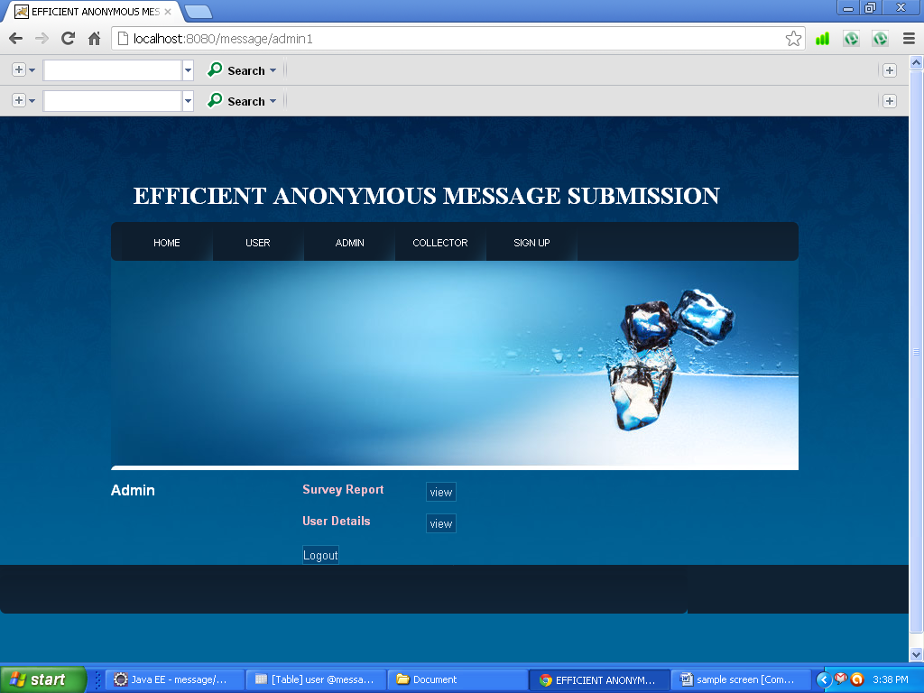

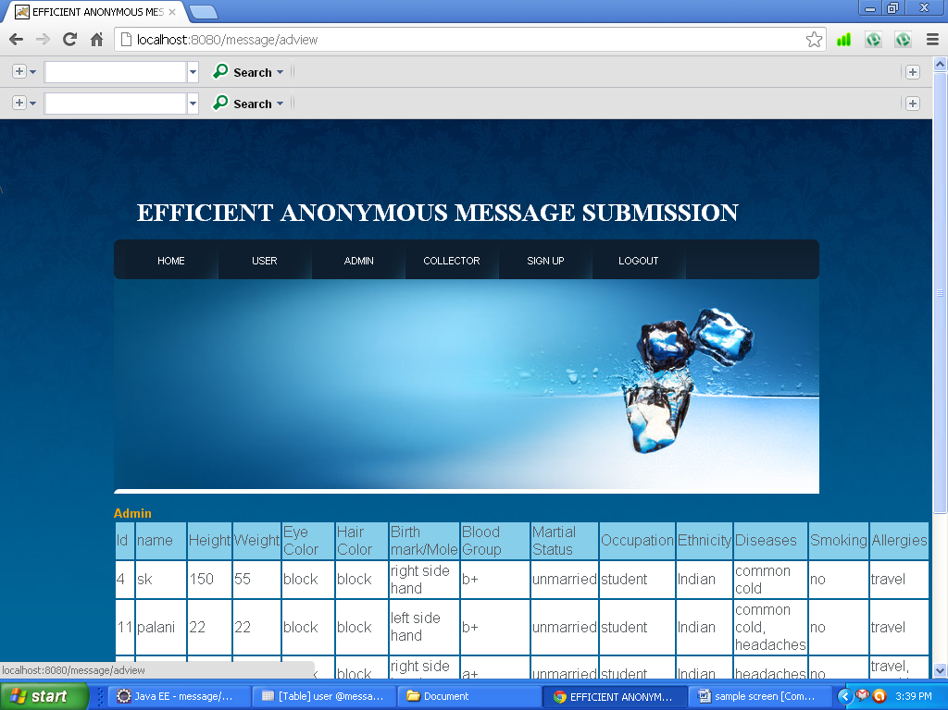

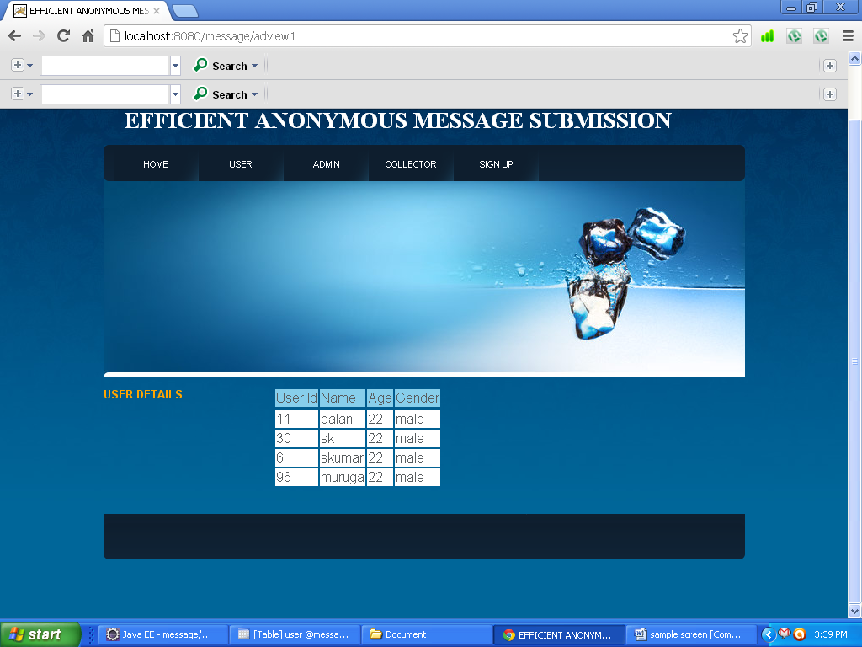

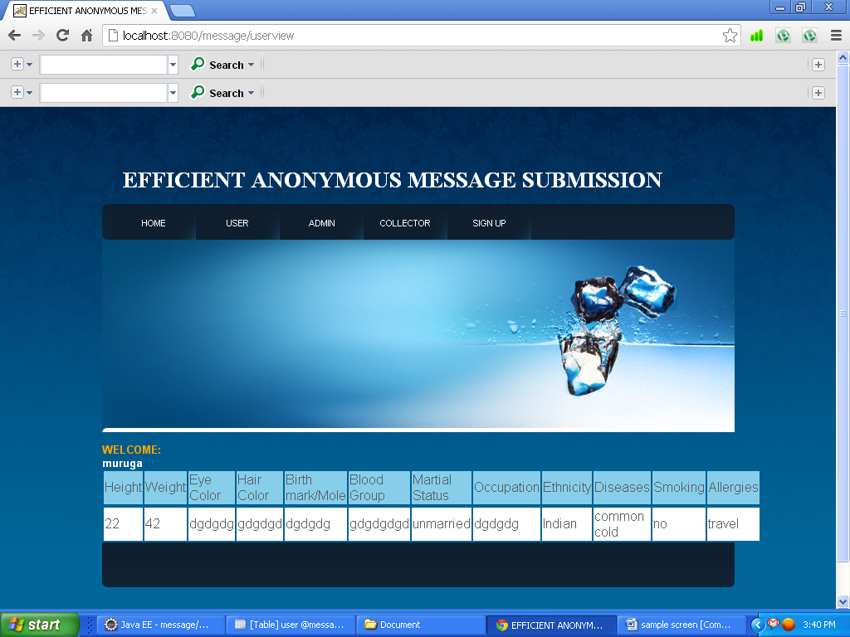

**SAMPLE CODES:**

**<%@ page language="java" contentType="text/html; charset=ISO-8859-1"**

**pageEncoding="ISO-8859-1"%>**

**<%@ taglib prefix="s" uri="/struts-tags" %>**

**<html>**

**<head>**

**<title>EFFICIENT ANONYMOUS MESSAGE SUBMISSION</title>**

**<link rel="stylesheet" type="text/css" href="./css/default.css" media="screen" />**

**<link rel="stylesheet" type="text/css" href="./css/print.css" media="print" />**

**<link rel="stylesheet" type="text/css" href="css/Signup.css" media="screen" />**

**<script src="js/jquery-1.7.1.js" type="text/javascript"></script>**

**<script src="js/jey1.js" type="text/javascript"></script>**

**</head>**

**<body>**

**<div id="view">**

**<div id="head">**

**<div id="main">**

**<h1><font color="#FFFFFF" face="Times New Roman, Times, serif" >EFFICIENT ANONYMOUS MESSAGE SUBMISSION</font></h1>**

**</div>**

**<div id="mainMenu">**

**<ul> <li><a href="home.jsp">HOME<span></span></a></li>**

**<li><a href="user.jsp">USER<span></span></a></li>**

**<li><a href="admin.jsp">ADMIN<span></span></a></li>**

**<li><a href="collector.jsp">COLLECTOR<span></span></a></li>**

**<li><a href="sign_up.jsp">SIGN UP<span></span></a></li>**

**</ul>**

**</div>**

**<div id="logo"> <a href="" class="block">&nbsp;</a>**

**<h2></h2>**

**</div>**

**</div>**

**<div id="logg">**

**<form name="admin1" action="admin1" method=post>**

**<font color="white" size="4">Admin Login</font>**

**<br>**

**<div id="sss">**

**<div id="ss"><font color="pink" size="3">Name:</font></div>**

**<div id="ssx"><input type="text" name="name" id="name" placeholder="enter your name?"></div></div>**

**<div id="sss">**

**<div id="ss"><font color="pink" size="3">Password :</font></div>**

**<div id="ssx"><input type="password" name="password" id="password" placeholder="enter your password?"></div></div>**

**<div id="ss1">**

**<input id="submit" type="submit" value="submit"/></div>**

**</form>**

**</div>**

**<div id="foot">**

**</div>**

**</div>**

**</body>**

**</html>**

**<%@ page language="java" contentType="text/html; charset=ISO-8859-1"**

**pageEncoding="ISO-8859-1"%>**

**<%@ taglib prefix="s" uri="/struts-tags" %>**

**<html>**

**<head>**

**<title>EFFICIENT ANONYMOUS MESSAGE SUBMISSION</title>**

**<link rel="stylesheet" type="text/css" href="./css/default.css" media="screen" />**

**<link rel="stylesheet" type="text/css" href="./css/print.css" media="print" />**

**<link rel="stylesheet" type="text/css" href="css/Signup.css" media="screen" />**

**</head>**

**<body>**

**<div id="view">**

**<div id="head">**

**<div id="main">**

**<h1><font color="#FFFFFF" face="Times New Roman, Times, serif" >EFFICIENT ANONYMOUS MESSAGE SUBMISSION</font></h1>**

**</div>**

**<div id="mainMenu">**

**<ul>**

**<li><a href="home.jsp">HOME<span></span></a></li>**

**<li><a href="user.jsp">USER<span></span></a></li>**

**<li><a href="admin.jsp">ADMIN<span></span></a></li>**

**<li><a href="collector.jsp">COLLECTOR<span></span></a></li>**

**<li><a href="sign_up.jsp">SIGN UP<span></span></a></li>**

**</ul>**

**</div>**

**<div id="logo"> <a href="" class="block">&nbsp;</a>**

**<h2></h2>**

**</div>**

**</div>**

**<br>**

**<font color="white" size="3"><b>Admin</b></font>**

**<div id="collector">**

**<form action="adview" name="adview" method=post>**

**<div id="sss">**

**<div id="ss11"><font color="pink" size="2"><b>Survey Report</b></font></div>**

**<div id="ssx"><input type="submit" value=" view "></div></div></form>**

**</div>**

**<div id="collector">**

**<form action="adview1" name="adview1" method=post>**

**<div id="sss">**

**<div id="ss11"><font color="pink" size="2"><b>User Details</b></font></div>**

**<div id="ssx"><input type="submit" value=" view "></div></div></form>**

**</div>**

**<div id="collector">**

**<form action="logout" name="logout" method=post>**

**<div id="ss11"></div>**

**<div id="ssx">**

**<input type="submit" value="Logout"></div></form>**

**</div></div>**

**<div id="foot">**

**</div>**

**</body>**

**</html>**

**<%@ page language="java" contentType="text/html; charset=ISO-8859-1"**

**pageEncoding="ISO-8859-1"%>**

**<%@ taglib prefix="s" uri="/struts-tags" %>\**

**<html>**

**<head>**

**<title>EFFICIENT ANONYMOUS MESSAGE SUBMISSION</title>**

**<link rel="stylesheet" type="text/css" href="./css/default.css" media="screen" />**

**<link rel="stylesheet" type="text/css" href="./css/print.css" media="print" />**

**<link rel="stylesheet" type="text/css" href="css/Signup.css" media="screen" />**

**<script src="js/jquery-1.7.1.js" type="text/javascript"></script>**

**<script src="js/jey1.js" type="text/javascript"></script>**

**</head>**

**<body>**

**<div id="view">**

**<div id="head">**

**<div id="main">**

**<h1><font color="#FFFFFF" face="Times New Roman, Times, serif" >EFFICIENT ANONYMOUS MESSAGE SUBMISSION</font></h1>**

**</div>**

**<div id="mainMenu">**

**<ul>**

**<li><a href="home.jsp">HOME<span></span></a></li>**

**<li><a href="user.jsp">USER<span></span></a></li>**

**<li><a href="admin.jsp">ADMIN<span></span></a></li>**

**<li><a href="collector.jsp">COLLECTOR<span></span></a></li>**

**<li><a href="sign_up.jsp">SIGN UP<span></span></a></li>**

**<li><a href="logout.jsp">LOGOUT<span></span></a></li>**

**</ul>**

**</div>**

**<div id="logo"> <a href="" class="block">&nbsp;</a>**

**<h2></h2>**

**</div>**

**</div>**

**<br>**

**<div id="ss">**

**<font color="orange" size="2"><b>Admin</b></font><font color="white" size="2">**

**<b></b></font>**

**</div>**

**<br>**

**<table><tr><td bgcolor="skyblue">Id</td><td bgcolor="skyblue">name</td>**

**<td bgcolor="skyblue">Height</td><td bgcolor="skyblue">Weight</td><td bgcolor="skyblue">Eye Color</td><td bgcolor="skyblue">Hair Color</td>**

**<td bgcolor="skyblue">Birth mark/Mole</td><td bgcolor="skyblue">Blood Group</td><td bgcolor="skyblue">Martial Status</td>**

**<td bgcolor="skyblue">Occupation</td><td bgcolor="skyblue">Ethnicity</td><td bgcolor="skyblue">Diseases</td>**

**<td bgcolor="skyblue">Smoking</td><td bgcolor="skyblue">Allergies</td>**

**</tr>**

**<s:iterator value="userArray3">**

**<tr>**

**<td bgcolor="white"><s:property value="id" /> </td>**

**<td bgcolor="white"><s:property value="name" /> </td>**

**<td bgcolor="white"><s:property value="height" /> </td>**

**<td bgcolor="white"><s:property value="weight" /> </td>**

**<td bgcolor="white"><s:property value="eye" /> </td>**

**<td bgcolor="white"><s:property value="hair" /> </td>**

**<td bgcolor="white"><s:property value="mole" /> </td>**

**<td bgcolor="white"><s:property value="blood" /> </td>**

**<td bgcolor="white"><s:property value="martial" /> </td>**

**<td bgcolor="white"><s:property value="occupation" /> </td>**

**<td bgcolor="white"><s:property value="ethnicity" /> </td>**

**<td bgcolor="white"><s:property value="diseases" /> </td>**

**<td bgcolor="white"><s:property value="smoke" /> </td>**

**<td bgcolor="white"><s:property value="allergies" /> </td>**

**</tr>**

**</s:iterator>**

**</table>**

**<div id="foot">**

**</div>**

**</div>**

**</body>**

**</html>**

**<%@ page language="java" contentType="text/html; charset=ISO-8859-1"**

**pageEncoding="ISO-8859-1"%>**

**<%@ taglib prefix="s" uri="/struts-tags" %>**

**<html>**

**<head>**

**<title>EFFICIENT ANONYMOUS MESSAGE SUBMISSION</title>**

**<link rel="stylesheet" type="text/css" href="./css/default.css" media="screen" />**

**<link rel="stylesheet" type="text/css" href="./css/print.css" media="print" />**

**<link rel="stylesheet" type="text/css" href="css/Signup.css" media="screen" />**

**<script src="js/jquery-1.7.1.js" type="text/javascript"></script>**

**<script src="js/jey1.js" type="text/javascript"></script>**

**</head>**

**<body>**

**<div id="view">**

**<div id="head">**

**<div id="main">**

**<h1><font color="#FFFFFF" face="Times New Roman, Times, serif" >EFFICIENT ANONYMOUS MESSAGE SUBMISSION</font></h1>**

**</div>**

**<div id="mainMenu">**

**<ul>**

**<li><a href="home.jsp">HOME<span></span></a></li>**

**<li><a href="user.jsp">USER<span></span></a></li>**

**<li><a href="admin.jsp">ADMIN<span></span></a></li>**

**<li><a href="collector.jsp">COLLECTOR<span></span></a></li>**

**<li><a href="sign_up.jsp">SIGN UP<span></span></a></li>**

**</ul>**

**</div>**

**<div id="logo"> <a href="" class="block">&nbsp;</a>**

**<h2></h2>**

**</div>**

**</div>**

**<br>**

**<div id="ss">**

**<font color="orange" size="2"><b>USER DETAILS</b></font><font color="white" size="2">**

**<b></b></font>**

**</div>**

**<div id="loggg">**

**<table><tr><td bgcolor="skyblue">User Id</td><td bgcolor="skyblue">Name</td>**

**<td bgcolor="skyblue">Age</td><td bgcolor="skyblue">Gender</td>**

**</tr>**

**<tr><s:iterator value="userArray4">**

**<tr><td bgcolor="white"><s:property value="id" /></td>**

**<td bgcolor="white"><s:property value="name" /></td>**

**<td bgcolor="white"><s:property value="age" /></td>**

**<td bgcolor="white"><s:property value="gender" /></td>**

**</s:iterator></tr>**

**</table>**

**</div>**

**<div id="foot">**

**</div>**

**</div>**

**</body>**

**</html>**

**<%@ page language="java" contentType="text/html; charset=ISO-8859-1"**

**pageEncoding="ISO-8859-1"%>**

**<%@ taglib prefix="s" uri="/struts-tags" %>**

**<html>**

**<head>**

**<title>EFFICIENT ANONYMOUS MESSAGE SUBMISSION</title>**

**<link rel="stylesheet" type="text/css" href="./css/default.css" media="screen" />**

**<link rel="stylesheet" type="text/css" href="./css/print.css" media="print" />**

**<link rel="stylesheet" type="text/css" href="css/Signup.css" media="screen" />**

**<script src="js/jquery-1.7.1.js" type="text/javascript"></script>**

**<script src="js/jey1.js" type="text/javascript"></script>**

**</head>**

**<body>**

**<div id="view">**

**<div id="head">**

**<div id="main">**

**<h1><font color="#FFFFFF" face="Times New Roman, Times, serif" >EFFICIENT ANONYMOUS MESSAGE SUBMISSION</font></h1>**

**</div>**

**<div id="mainMenu">**

**<ul> <li><a href="home.jsp">HOME<span></span></a></li>**

**<li><a href="user.jsp">USER<span></span></a></li>**

**<li><a href="admin.jsp">ADMIN<span></span></a></li>**

**<li><a href="collector.jsp">COLLECTOR<span></span></a></li>**

**<li><a href="sign_up.jsp">SIGN UP<span></span></a></li>**

**</ul>**

**</div>**

**<div id="logo"> <a href="" class="block">&nbsp;</a>**

**<h2></h2>**

**</div>**

**</div>**

**<div id="logg">**

**<form name="collector1" action="collector1" method=post>**

**<font color="white" size="4">Collector Login</font>**

**<br>**

**<div id="sss">**

**<div id="ss"><font color="pink" size="3">Name:</font></div>**

**<div id="ssx"><input type="text" name="name" id="name" placeholder="enter your name?"></div></div>**

**<div id="sss">**

**<div id="ss"><font color="pink" size="3">Password :</font></div>**

**<div id="ssx"><input type="password" name="password" id="password" placeholder="enter your password?"></div></div>**

**<div id="ss1">**

**<input id="submit" type="submit" value="submit"/></div>**

**</form>**

**</div>**

**<div id="foot">**

**</div>**

**</div>**

**</body>**

**</html>**